New Matrix

**Extro Kia Table Mounted Sink Mixer with Swivel Spout (Dual Handle)**

**📝 Product Description:**

The Extro Kia Table Mounted Sink Mixer is an elegant dual-handle faucet designed for deck mounting, equipped with a high-arched swivel spout that provides full coverage and convenience for kitchen or basin use.

**⭐ 5 Key Features (Single Line Each):**

* Dual lever design allows precise control of hot and cold water
* 360° swivel spout for maximum reach and flexibility
* Durable brass body with mirror-finish chrome plating
* Smooth operation with quarter-turn ceramic disc cartridges
* Ideal for modern kitchen or basin installations

**📐 Product Specifications:**

* **Material:** Brass
* **Finish:** Chrome-plated
* **Mount Type:** Table/deck-mounted
* **Spout Type:** Swivel spout
* **Handle Type:** Dual lever handles
* **Cartridge Type:** Quarter-turn ceramic disc
* **Usage:** Kitchen sinks or basin counters

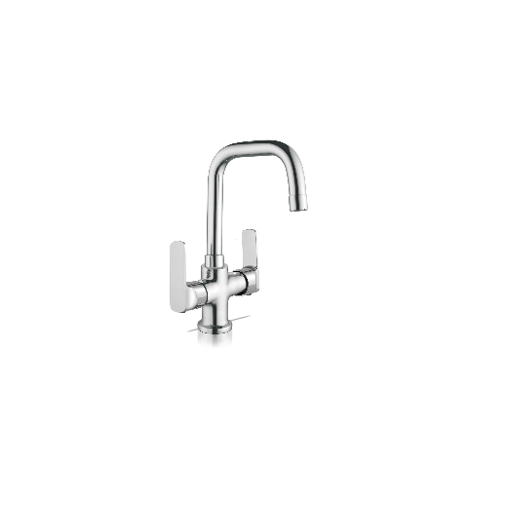

**Extro Kia Wall Mixer with L-Bend for Overhead and Hand Shower**

**📝 Product Description:**

The Extro Kia Wall Mixer is a sleek, wall-mounted fixture combining modern style and multi-functionality, offering seamless switching between overhead shower and hand shower with a robust, chrome-plated brass body.

**⭐ 5 Key Features (Single Line Each):**

* Dual-handle wall mixer with provision for overhead and hand shower
* Sleek lever handles ensure easy and smooth operation
* Anti-corrosive chrome finish for long-lasting shine
* Made with high-quality brass for superior durability
* Perfect for contemporary bathroom spaces

**📐 Product Specifications:**

* **Material:** Brass
* **Finish:** Chrome-plated
* **Mount Type:** Wall-mounted
* **Type:** Wall Mixer with L-bend
* **Handle Type:** Dual lever handles
* **Function:** Controls overhead shower and hand shower
* **Application:** Bathroom – shower area

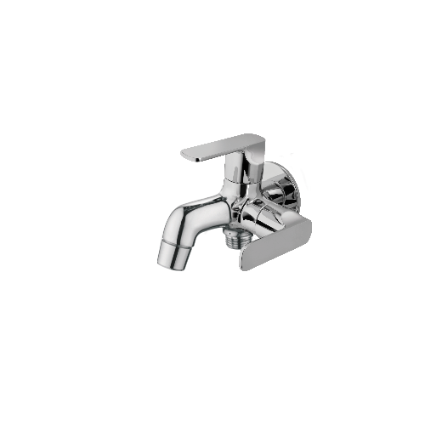

**Extro Modern Wall Mixer with L-Bend for Overhead & Hand Shower**

**📝 Product Description:**

The Extro Modern Wall Mixer is an elegantly designed dual-control faucet that combines water flow precision with seamless switching between overhead and hand showers—ideal for contemporary bathrooms.

**⭐ 5 Key Features (Single Line Each):**

* Dual-lever design offers smooth and independent hot/cold water control
* L-bend provision for simultaneous use with overhead and hand showers
* Mirror-like chrome finish for aesthetic appeal and rust resistance
* Brass body ensures long-term durability and strength
* Ergonomic lever handles for easy grip and operation

**📐 Product Specifications:**

* **Material:** Heavy-duty brass
* **Finish:** Premium chrome plating
* **Mount Type:** Wall-mounted
* **Type:** Wall mixer with L-bend attachment
* **Control Mechanism:** Dual-lever operation
* **Application:** Suitable for bathroom shower zones
* **Inlet Connection:** Standard wall inlet with overhead output

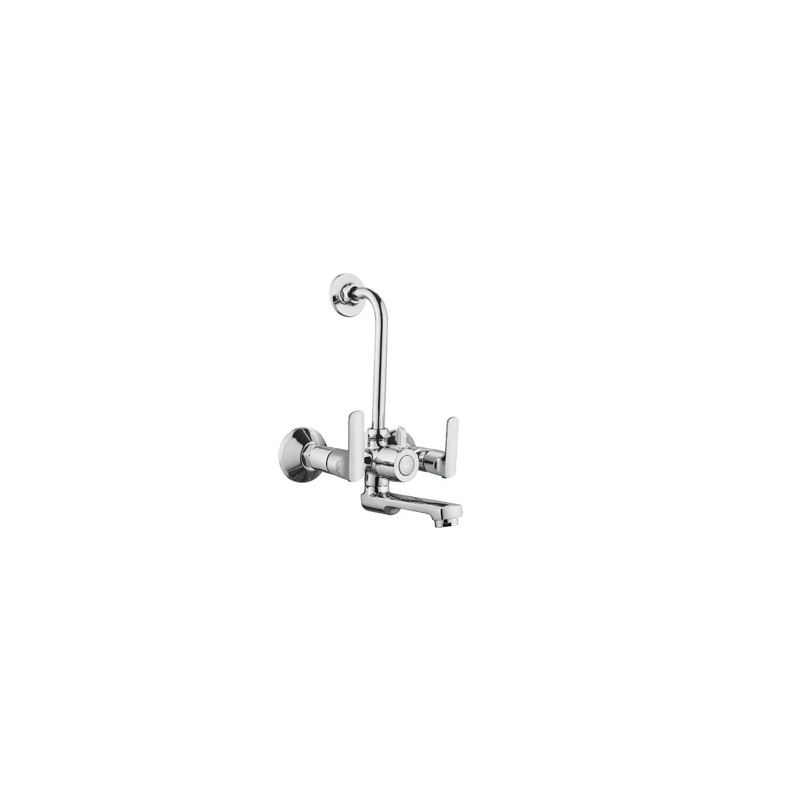

**Extro Wall Mounted Sink Mixer with Swivel Spout**

**📝 Product Description:**

The Extro Wall Mounted Sink Mixer with Swivel Spout combines functionality and modern design, allowing precise control of hot and cold water with a rotating spout—perfect for kitchen and utility sinks.

**⭐ 5 Key Features (Single Line Each):**

* Wall-mounted design ensures space-saving and clutter-free installation
* Dual-lever system allows accurate temperature and flow control
* Swivel spout offers flexible reach for wider sink coverage
* Chrome-plated finish resists corrosion and adds a glossy touch
* High-quality brass construction ensures long-lasting durability

**📐 Product Specifications:**

* **Material:** Solid brass body
* **Finish:** Chrome-plated
* **Mount Type:** Wall-mounted
* **Spout Type:** 360° rotating swivel spout
* **Operation:** Dual-lever control
* **Application:** Ideal for kitchen and wash basin areas
* **Connection Type:** Standard wall inlet

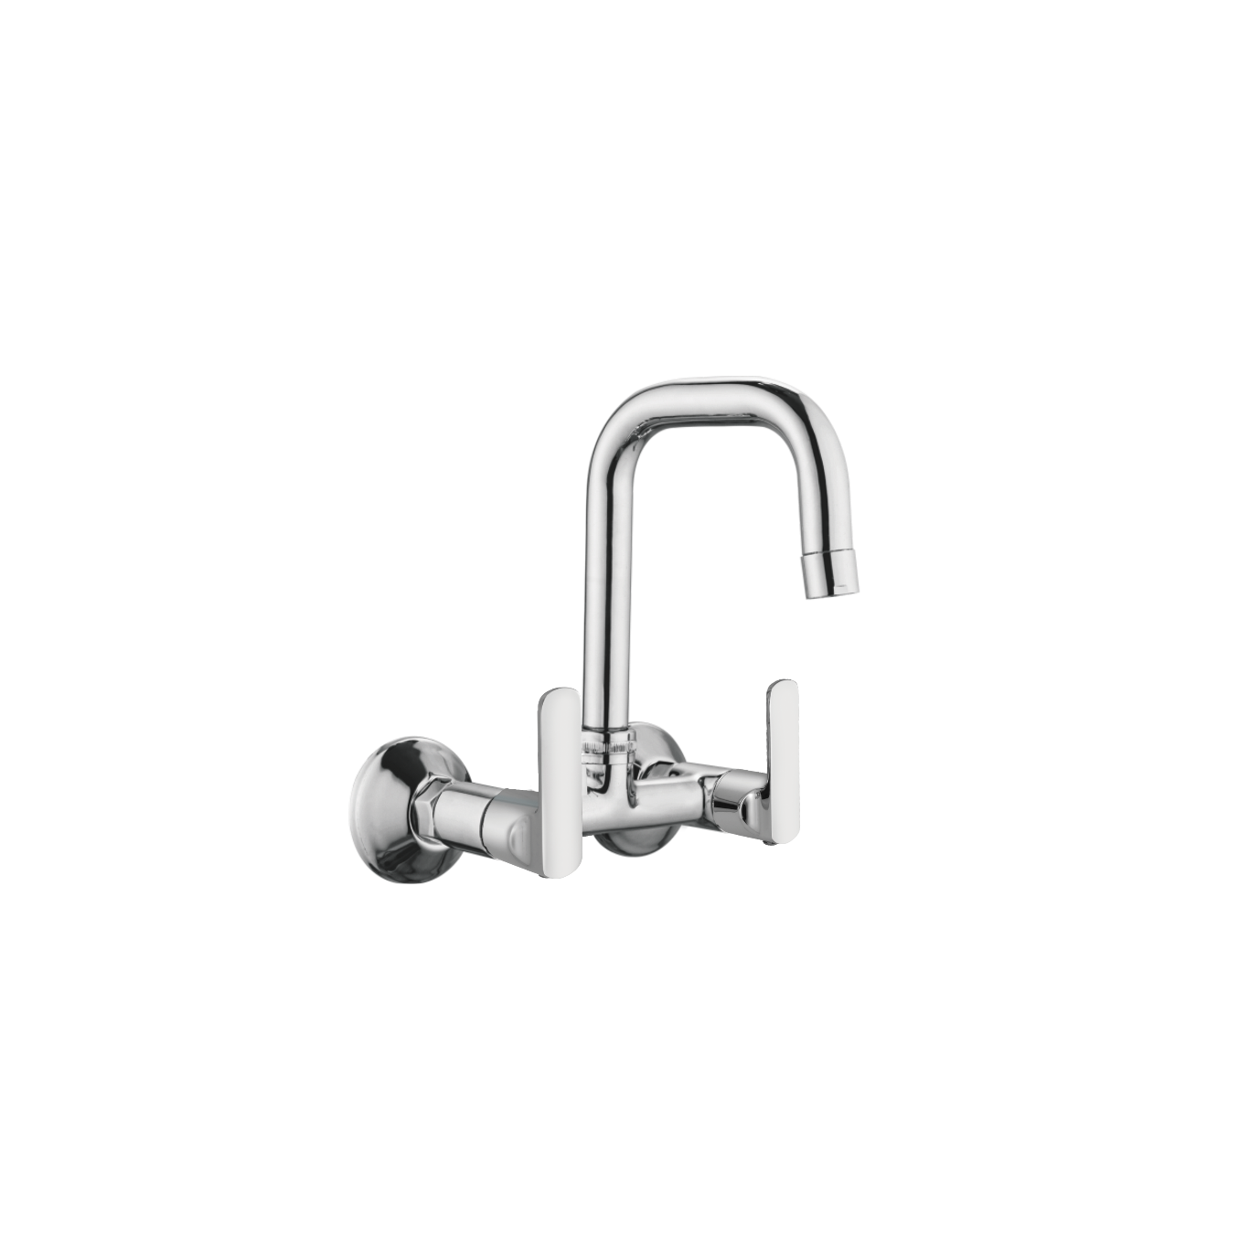

**Extro Table Mounted Sink Mixer with Swivel Spout**

**📝 Product Description:**

This modern table-mounted sink mixer features a high curved swivel spout and a single-lever control, combining style with functionality for effortless use in kitchen or utility areas.

**⭐ 5 Key Features (Single Line Each):**

* High-rise swivel spout offers enhanced sink access and flexibility
* Single-lever operation ensures smooth flow and temperature control
* Durable chrome-plated brass resists corrosion and tarnish
* Compact table-mounted design saves space and simplifies installation
* Ideal for modern kitchens and countertops

**📐 Product Specifications:**

* **Material:** Solid brass body
* **Finish:** Chrome-plated
* **Mount Type:** Table-mounted (deck mounted)
* **Spout Type:** 360° rotating swivel spout
* **Operation:** Single lever
* **Usage Area:** Kitchen, Pantry, Utility Sink
* **Cartridge Type:** Ceramic disc for long life

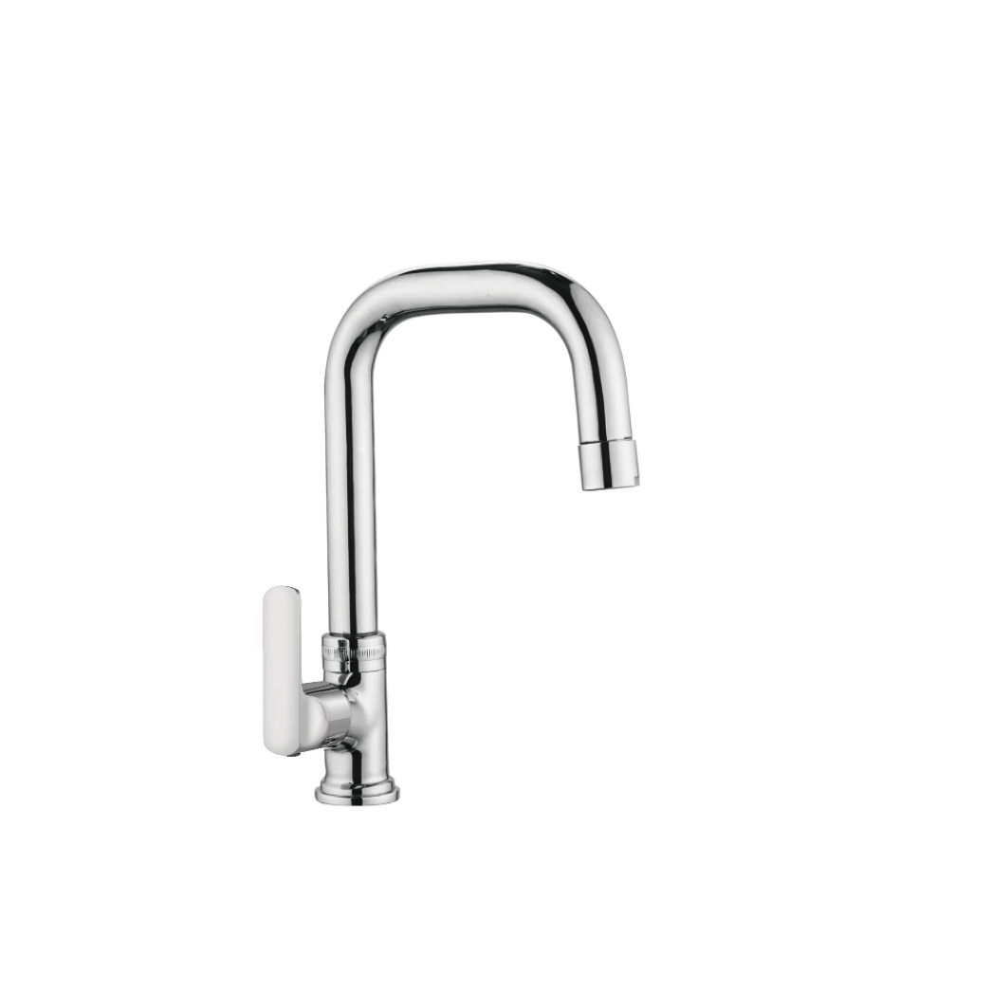

**Extro Wall Mounted Sink Tap with Swivel Spout**

**📝 Product Description:**

A sleek and durable wall-mounted sink tap with a high-arc swivel spout and single lever for effortless water flow and control, perfect for kitchen and utility settings.

**⭐ 5 Key Features (Single Line Each):**

* Wall-mounted design ideal for compact kitchen or utility spaces
* High-rise swivel spout allows wide sink coverage and maneuverability
* Single lever ensures smooth and precise control of water flow
* Sturdy brass construction with chrome finish resists rust and tarnish
* Simple installation with standard wall inlet connection

**📐 Product Specifications:**

* **Material:** Solid brass body
* **Finish:** Chrome-plated
* **Mount Type:** Wall-mounted
* **Spout Type:** Rotating swivel spout
* **Operation:** Single lever control
* **Usage Area:** Kitchen, Pantry, Utility Sink
* **Cartridge:** Ceramic disc cartridge for durability

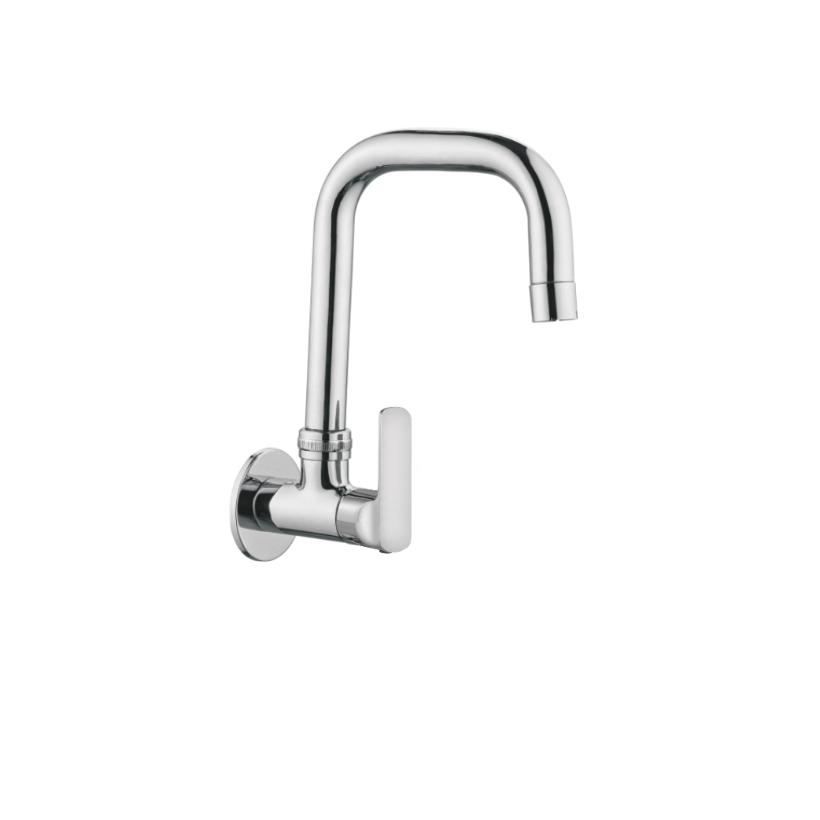

**Extro Angle Valve with Wall Flange and Dual Outlet**

**📝 Product Description:**

A versatile and compact angle valve designed for wall mounting, offering dual outlet control for geysers, washing machines, or health faucets, with sleek modern aesthetics and high durability.

**⭐ 5 Key Features (Single Line Each):**

* Dual outlet functionality for multi-purpose water connections
* Stylish single lever handle for smooth control
* Corrosion-resistant chrome finish ensures long-lasting shine
* Compact design with wall flange for clean installation
* Brass body construction for strength and longevity

**📐 Product Specifications:**

* **Material:** Solid brass
* **Finish:** Polished chrome
* **Mount Type:** Wall-mounted with flange
* **Control Type:** Single lever
* **Outlets:** Dual (main + auxiliary)
* **Application:** Geyser, washing machine, health faucet, etc.
* **Valve Type:** Quarter turn ceramic disc

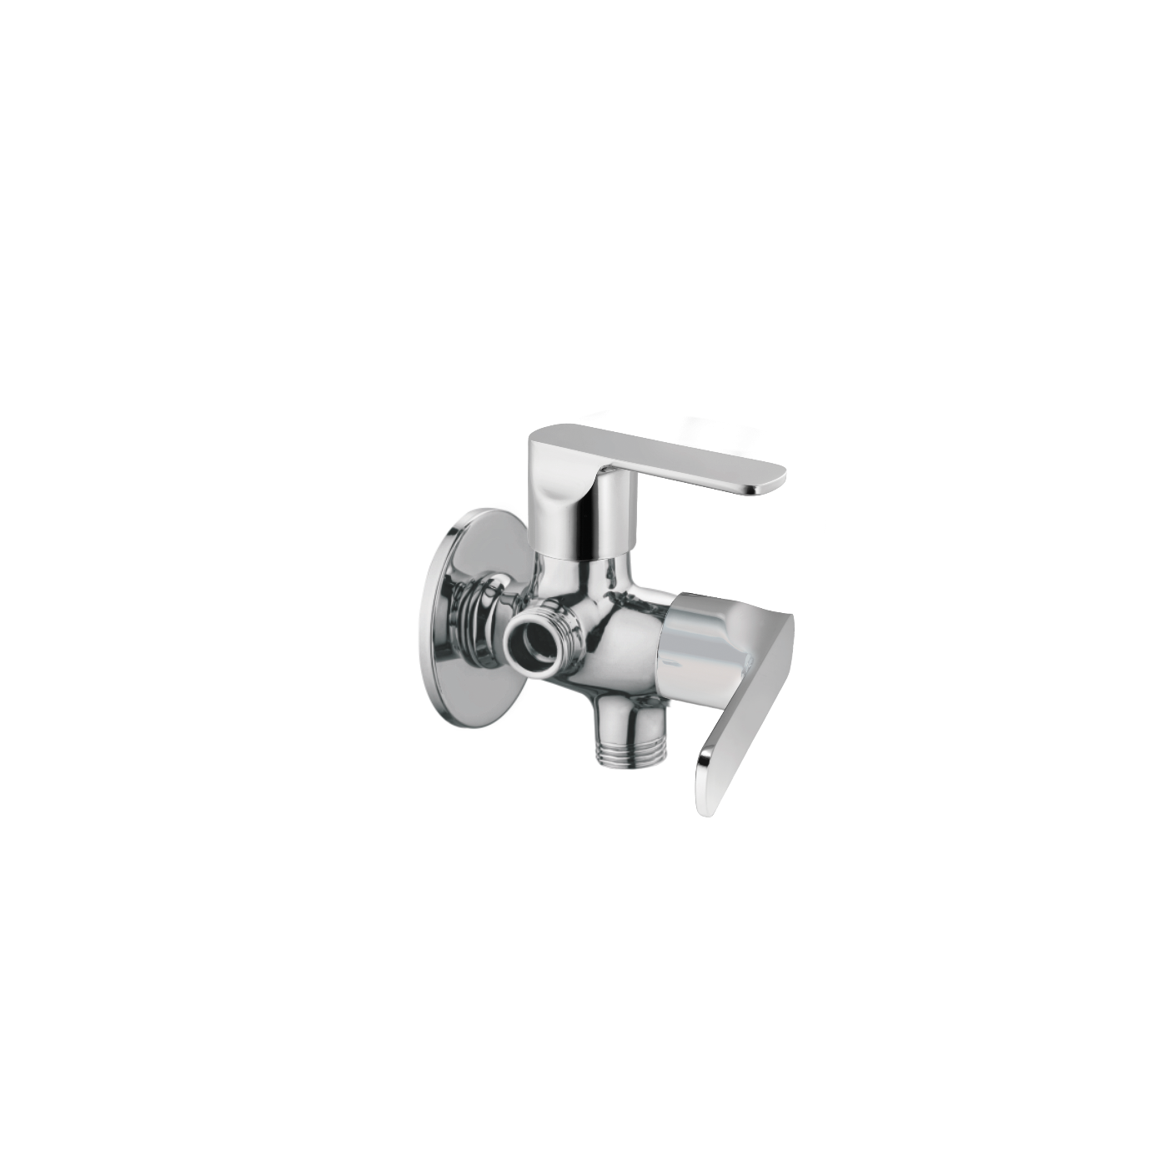

**Extro Basin Mixer with Single Lever**

**📝 Product Description:**

A sleek and contemporary basin mixer with a single lever design, ideal for modern wash areas offering smooth water flow control and premium finish.

**⭐ 5 Key Features (Single Line Each):**

* Single lever control for effortless temperature and flow adjustment
* Smooth and stylish design to complement any modern basin
* High-quality chrome finish resists tarnishing and corrosion
* Durable ceramic disc cartridge for leak-proof performance
* Easy to install with standard plumbing fittings

**📐 Product Specifications:**

* **Material:** Solid brass
* **Finish:** Polished chrome
* **Mount Type:** Deck mounted
* **Control Type:** Single lever
* **Cartridge:** 35mm ceramic disc cartridge
* **Suitable For:** Washbasins and vanity sinks
* **Connection Size:** Standard 1/2" BSP

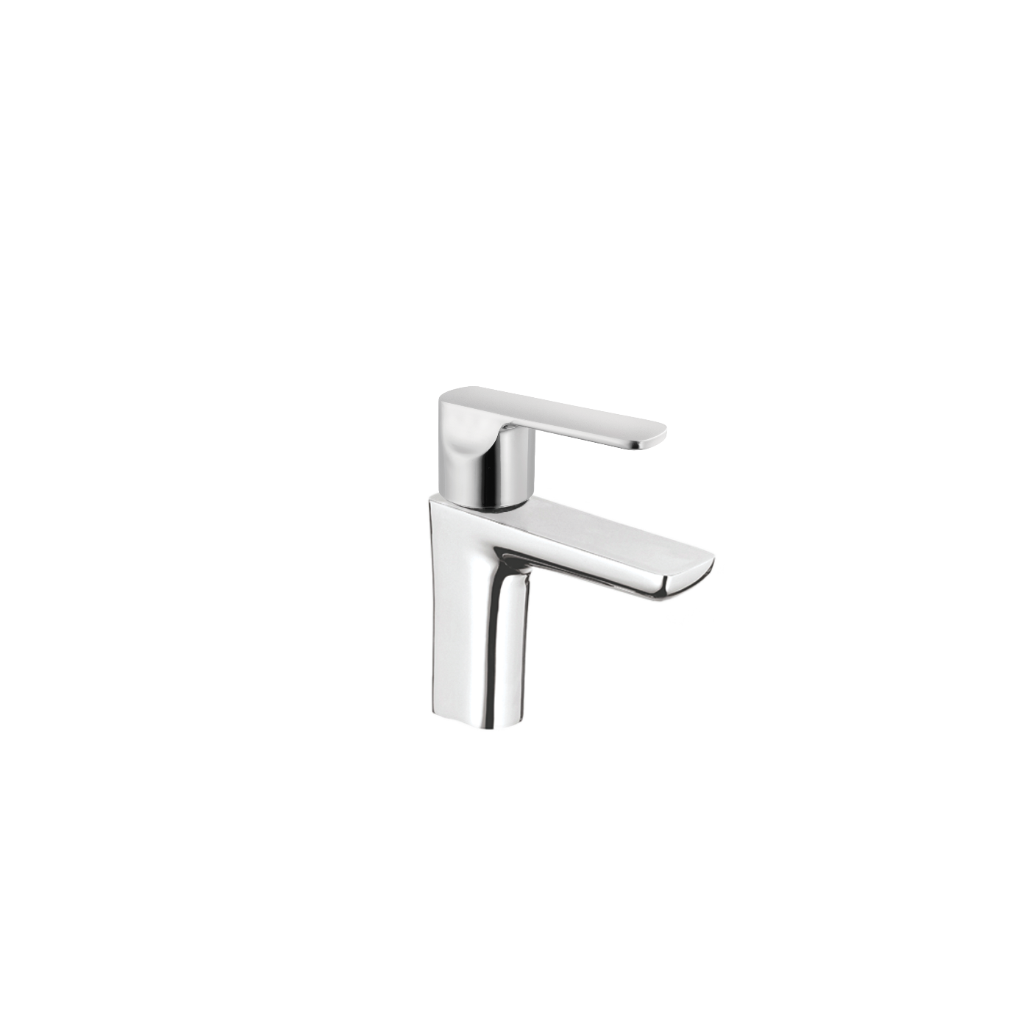

**Concealed Basin Mixer Body with Lever Handle**

**📝 Product Description:**

A durable and precision-engineered concealed basin mixer body with an elegant chrome-plated lever, ideal for in-wall installation in modern bathrooms or wash areas.

**⭐ 5 Key Features (Single Line Each):**

* Robust brass body ensures long-lasting performance
* Concealed design enhances wall aesthetics and space efficiency
* Sleek chrome-plated lever offers easy flow and temperature control
* Compatible with most standard ceramic cartridges
* Ideal for basin areas requiring a minimalist and clean look

**📐 Product Specifications:**

* **Material:** Forged brass body with chrome-plated handle
* **Mount Type:** Concealed wall installation
* **Handle Type:** Single lever
* **Finish:** Chrome handle with raw brass body
* **Cartridge Compatibility:** Standard 35mm ceramic cartridge
* **Inlet/Outlet Connection:** 1/2" BSP threaded
* **Application:** Bathroom basins and wash counters

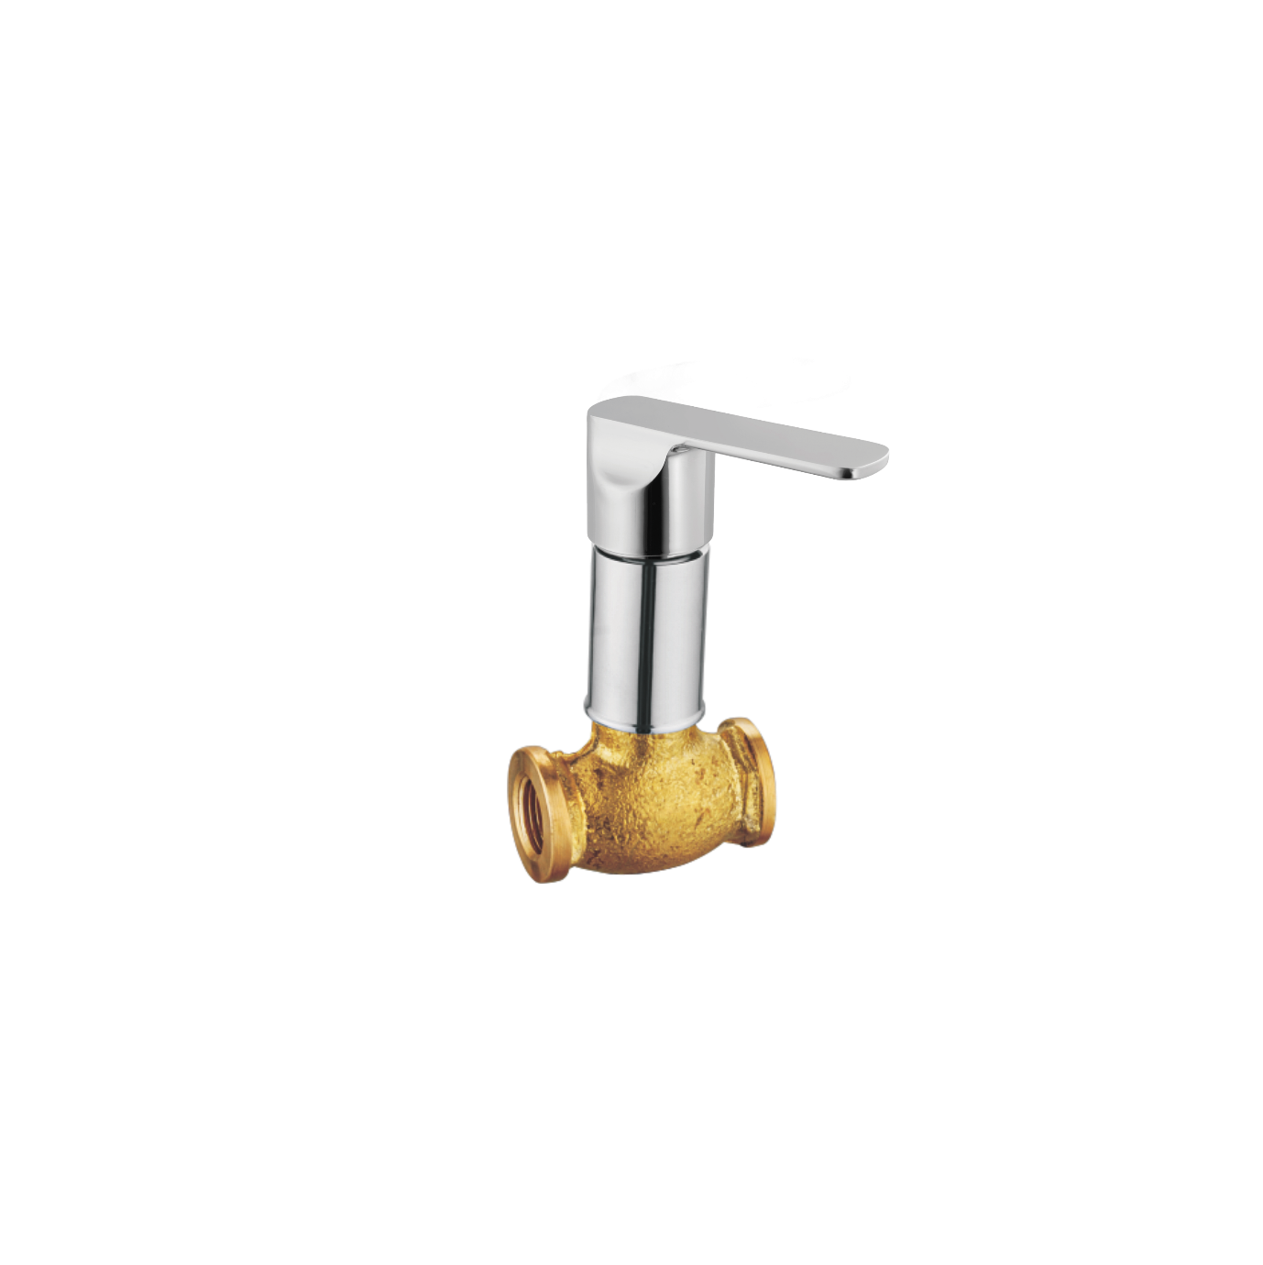

**Angle Valve with Handle**

**📝 Product Description:**

A sleek and durable angle valve with a designer handle, perfect for controlling water flow to fixtures like geysers, faucets, or health faucets in modern bathrooms.

**⭐ 5 Key Features (Single Line Each):**

* Precision-engineered for smooth operation and flow control
* Chrome-plated finish for corrosion resistance and shine
* Ergonomic handle for easy grip and operation
* Wall flange included for neat installation
* Compatible with all standard bathroom and kitchen fittings

**📐 Product Specifications:**

* **Material:** Brass body with chrome finish
* **Mount Type:** Wall-mounted with round flange
* **Handle Type:** Lever handle
* **Finish:** Mirror chrome-plated
* **Inlet/Outlet Size:** 1/2” BSP thread
* **Control Mechanism:** Quarter-turn
* **Application:** Geysers, faucets, WC fittings, and washing machines

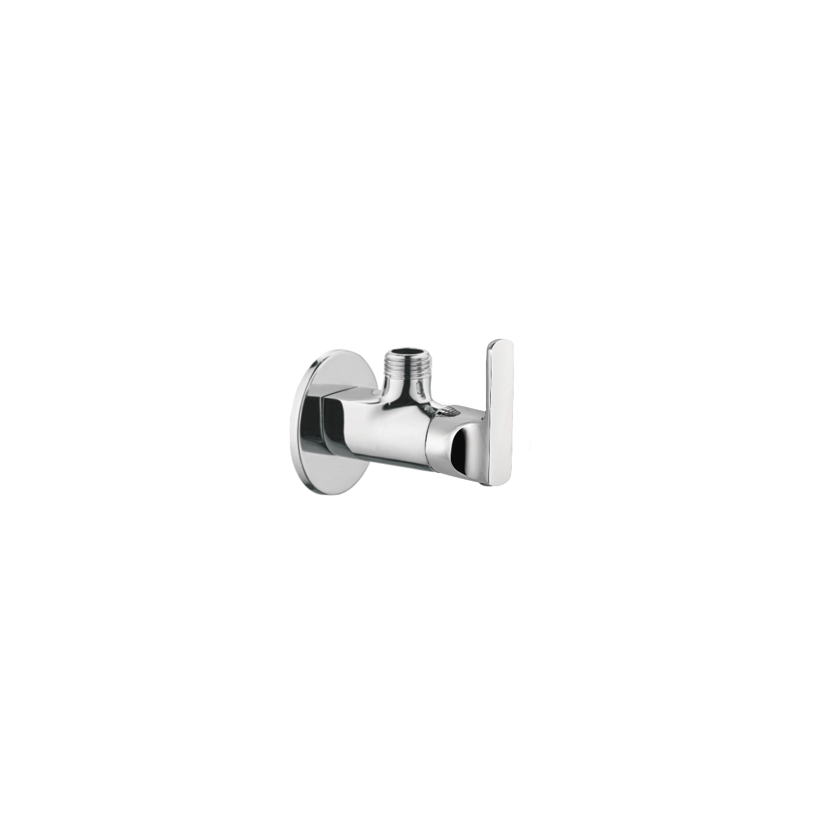

**Wall Mounted Bib Tap with Lever Handle**

**📝 Product Description:**

A contemporary wall-mounted bib tap with a single lever handle, offering smooth water control and elegant aesthetics for modern bathrooms or utility areas.

**⭐ 5 Key Features (Single Line Each):**

* Sleek single-lever design for effortless water control
* High-quality brass body with corrosion-resistant chrome finish
* Compact and minimalistic for wall installations
* Durable ceramic disc for leak-free performance
* Compatible with washbasins, utility areas, or garden use

**📐 Product Specifications:**

* **Material:** Brass with chrome plating
* **Mount Type:** Wall-mounted
* **Handle Type:** Single lever
* **Finish:** Polished chrome
* **Inlet Connection:** 1/2" BSP thread
* **Valve Mechanism:** Ceramic disc cartridge
* **Usage:** Bathrooms, utility sinks, washing areas

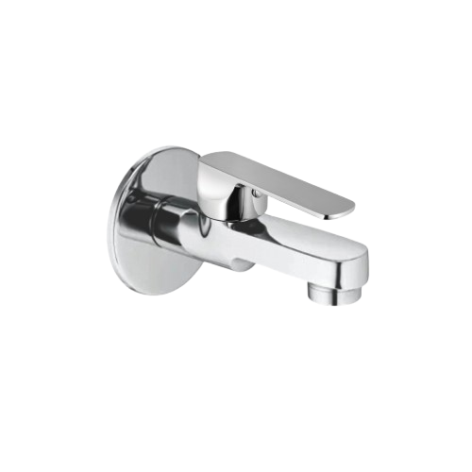

**Extended Wall Mounted Bib Tap with Lever Handle**

**📝 Product Description:**

A premium extended-reach wall-mounted bib tap featuring a sleek lever handle and chrome finish, ideal for kitchen sinks or utility areas requiring extended water projection.

**⭐ 5 Key Features (Single Line Each):**

* Extended spout design for wider reach and convenience
* Single lever operation for precise water control
* Rust- and corrosion-resistant chrome-plated brass body
* Ceramic cartridge ensures long-lasting, leak-free use
* Ideal for kitchens, utility zones, and wall-mounted setups

**📐 Product Specifications:**

* **Material:** Brass body with chrome finish
* **Mount Type:** Wall-mounted
* **Handle Type:** Single lever
* **Spout Type:** Extended straight spout
* **Finish:** Mirror polished chrome
* **Connection Size:** 1/2" BSP
* **Valve Mechanism:** Ceramic disc cartridge
* **Applications:** Kitchen sinks, washing areas, utility counters

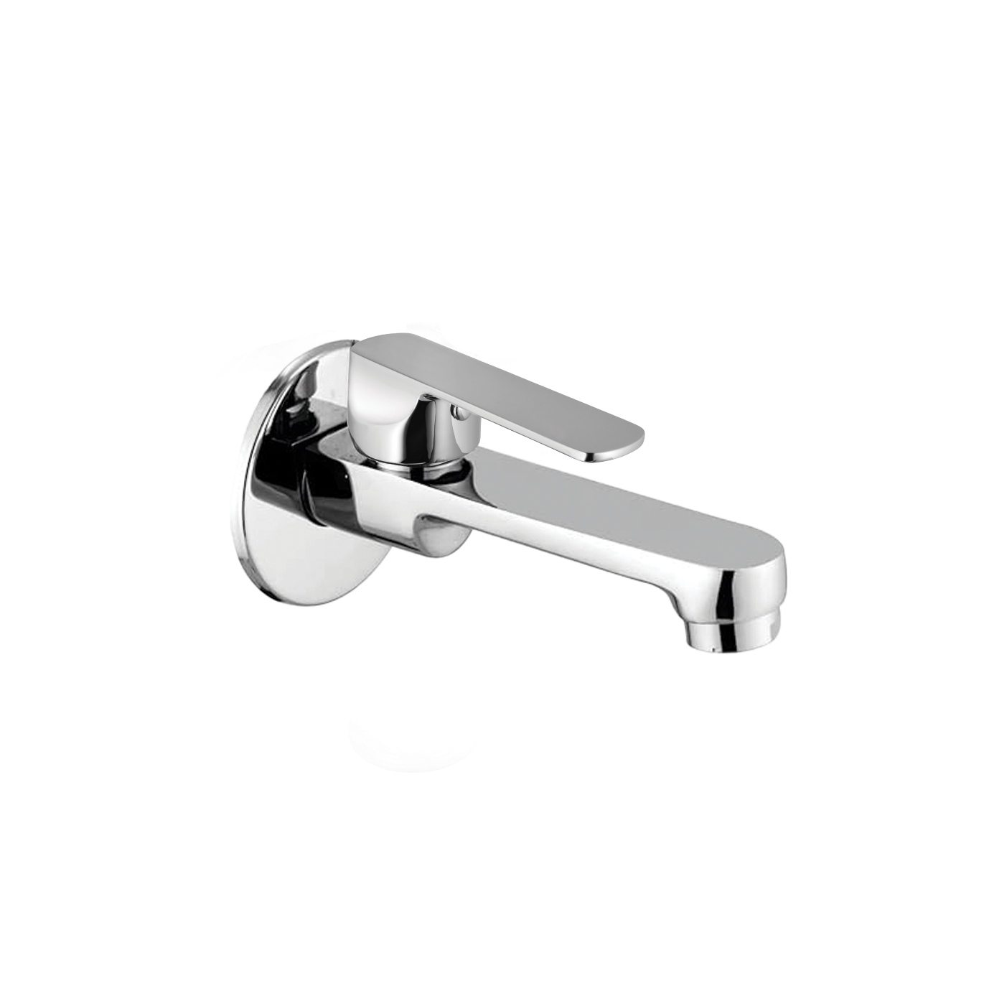

**Wall Mixer with L-Bend Pipe (Telephonic Shower Provision)**

**📝 Product Description:**

A robust wall-mounted mixer faucet with an "L" bend pipe and telephonic shower attachment support. Perfect for bath areas, it enables controlled flow between tap and shower via diverter.

**⭐ 5 Key Features (Single Line Each):**

* L-bend pipe provides direct overhead shower connection
* Dual-lever control ensures precise hot and cold water mixing
* In-built diverter for easy switch between spout and shower
* Mirror finish with rust- and corrosion-resistant body
* Heavy-duty brass construction for long-lasting durability

**📐 Product Specifications:**

* **Material:** Brass with chrome finish
* **Mount Type:** Wall-mounted
* **Spout Type:** Short body with down outlet
* **Handle Type:** Dual lever with central diverter knob
* **Inlet Connections:** 3/4" BSP hot & cold inlets
* **Shower Pipe:** Included L-bend pipe with shower outlet
* **Finish:** Glossy chrome-plated
* **Application:** Bathrooms – shower and bath tub areas

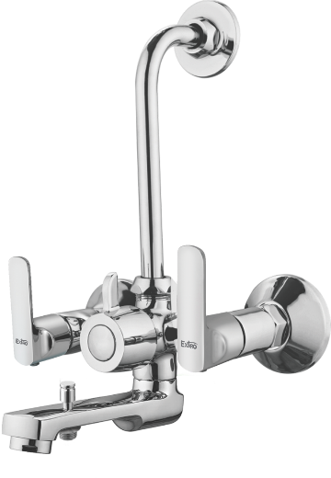

**Matrix Single Lever Basin Mixer (Without Popup Waste)**

**📝 Product Description:**

A sleek, modern single-lever basin mixer designed for countertop wash basins. Combines elegant aesthetics with smooth operation and water-saving functionality.

**⭐ 5 Key Features (Single Line Each):**

* Single lever operation for effortless flow and temperature control
* Aerator ensures smooth, splash-free water flow
* Corrosion-resistant chrome finish maintains shine
* Sturdy brass body with long-lasting ceramic cartridge
* Compact and stylish design ideal for modern bathrooms

**📐 Product Specifications:**

* **Material:** Brass body with chrome plating
* **Mount Type:** Deck-mounted (countertop installation)
* **Cartridge:** 35mm ceramic disc cartridge
* **Finish:** Glossy chrome
* **Control Type:** Single lever for hot & cold mixing
* **Aerator Type:** Foam flow
* **Inlet Connection:** Flexible braided hoses (1/2" BSP)
* **Application:** Bathroom basin / vanity basin

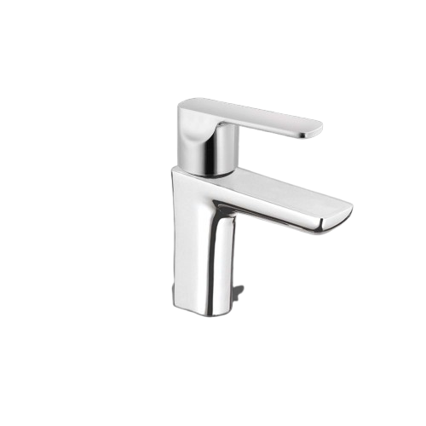

**Matrix Wall Mixer Spout – 2-in-1 with Lever Handle**

**📝 Product Description:**

A premium wall-mounted spout mixer that offers seamless control of water flow and temperature, ideal for use with wash basins or bathtubs. Its contemporary design enhances modern bathroom interiors while ensuring functionality.

**⭐ 5 Key Features (Single Line Each):**

* Sleek single-lever operation for precise temperature and flow control
* Wall-mounted design saves space and offers clean aesthetics
* Mirror-finish chrome plating ensures long-lasting shine
* Solid brass construction ensures durability and corrosion resistance
* Fitted with a foam flow aerator for smooth, splash-free water output

**📐 Product Specifications:**

* **Material:** Brass with chrome finish
* **Mount Type:** Wall-mounted
* **Handle Type:** Single lever
* **Cartridge:** 35mm ceramic disc cartridge
* **Finish:** Polished chrome
* **Water Flow:** Foam flow with aerator
* **Installation Type:** Concealed body with exposed spout
* **Application:** Suitable for wash basin, bath area, or utility sink

